Multiple-choice section

|  |  |  |  |  |  |  |  |  |  |  |  |  |
| --- | --- | --- | --- | --- | --- | --- | --- | --- | --- | --- | --- | --- |
| Question | 1 | 2 | 3 | 4 | 5 | 6 | 7 | 8 | 9 | 10 | 11 | 12 |
| Answer | C | B | D | B | A | D | D | B | C | C | B | A |

Question 1 [5.1]

C

Multiply the number of bags by the number of lollies per bag first, then subtract q.

Question 2 [5.1]

B

x + 30 is the volume. If  is consumed then  remains.

Question 3 [5.2]

D



Question 4 [5.1]

B

6n is subtracted from n2.

Question 5 [5.6]

A

When multiplying numbers, the order does not matter, so yzx is the same as xyz.

Question 6 [5.6]

D

Collect like terms.

3p – 4p = -p

5q – 4q = q

-p + q is the same as q – p.

Question 7 [5.3]

D

A number 3 less than x is x – 3. Product means multiply.

Question 8 [5.4]

B



Question 9 [5.4]

C

C is incorrect because  =  = 2 not 3

Question 10 [5.7]

C

The point is (-1, -2). Both x and y are negative, so this is the third quadrant.

Question 11 [5.7]

B

(3, 6) has the highest y-value.

Question 12 [5.8]

A

y = 1 + 2x

Multiple-choice total marks: 12

Short answer section

Question 13 4 marks [5.3, 5.7]

(a) A flowchart is a step-by-step instruction for performing a set task.

(b) A relationship means that variables are connected in some way so that changing the value of one affects the value of the other.

(c) The point (-2, 0) lies on the x-axis.

(d) The point (-1, -2) is in the third quadrant of the Cartesian plane.

Question 14 2 marks [5.6]

Non-like terms have different pronumeral components (e.g. 2a and 2b, 4a and 3ab).

Question 15 2 marks [5.1]

(a) a2 + b2

(b) 

Question 16 4 marks [5.1]

(a) x – 5

(b) x – 3

(c) x + (x – 5) + (x – 3) = 3x – 8

Question 17 4 marks [5.1]

(a) Each car has four wheels: 4p; bicycles: 2q; tricycles: 3r; unicycles: s  
So, the number of wheels altogether is 4p + 2q + 3r + s.

(b) 4p + 2q + 3 × 1 + 1 × 6 = 27  
4p + 2q + 9 = 27  
4p + 2q = 18  
Any of the following possible pairs, found using trial and error:

p = 1 and q = 7; p = 2 and q = 5; p = 3 and q = 3; p = 4 and q = 1

Question 18 4 marks [5.2]

(a) Let m = the cost of an adult’s ticket. Let n = the cost of a child’s ticket.

(b) 7n = 4m

(c) 14 child’s tickets = 2 × 7n = 2 × 4m = 8m

Question 19 4 marks [5.2]

(a) Let m = mass of one box.

(b) 40m +140 = 1140

(c) 40m + 140 = 1140  
40m = 1000  
m = 25 kg

Question 20 2 marks [5.3]

Let b = the amount that Beth spent. Let d = the amount the Daniel spent.

b =  + 25

Question 21 4 marks [5.3]

(a)

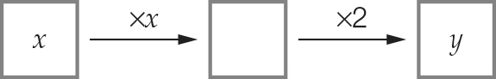

(b) y = 2x2

(c)

|  |  |  |  |  |
| --- | --- | --- | --- | --- |
| x | 3 | 4 | 5 | 10 |
| *y* | 18 | 32 | 50 | 200 |

Question 22 3 marks [5.3]

(a) y = 3(2x – 5)

(b) y = 30 – 4x

(c) y =

Question 23 2 marks [5.3]

y = 

Question 24 2 marks [5.3]

Divide each y value by 4 then subtract 6 to get x.

|  |  |  |  |  |
| --- | --- | --- | --- | --- |
| x | -5 | 1 | 9 | 6 |
| y | 4 | 28 | 60 | 48 |

Question 25 5 marks [5.3]

(a)

|  |  |  |  |  |
| --- | --- | --- | --- | --- |
| Number of cards, n | 10 | 12 | 20 | 100 |
| Cost to produce the cards C | 95 | 101 | 125 | 165 |

(b) C = 65 + 3n

(c) 65 + 3n < 1000   
Using trial and error: n = 311

Question 26 2 marks [5.4]

(a)  = 6 True

(b) 2 × 5 + 25 = 35 ≠ 20 False

Question 27 2 marks [5.4]

|  |  |  |  |  |
| --- | --- | --- | --- | --- |
| m | 5 | 10 | 12 | 14 |
| n | 100 | 50 | 30 | 10 |

Question 28 4 marks [5.4]

(a) Using trial and error: 5 × 72 = 245  
So it will take 7 seconds.

(b) d = 5 × 92 = 405 metres

Question 29 6 marks [5.5]

(a)

|  |  |  |  |  |  |
| --- | --- | --- | --- | --- | --- |
| Number of shapes, S | 1 | 2 | 3 | 4 | 5 |
| Number of matches, M | 7 | 13 | 19 | 25 | 31 |

(b) M = 6S + 1

(c) M = 6 × 30 + 1 = 181 mathces

(d) Using trial and error: 6 × 33 + 1 = 199, so 33 shapes

Question 30 6 marks [5.6]

(a) 22y + 5 (b) 0 (c) 3a2

(d) -3x + 4 (e) -p –q (f) 2m + 2n + 4

Question 31 2 marks [5.6]

Nelson saves $(y – x) each month. There are 24 months in 2 years so it will take him 2 years to save 24y – 24x dollars.

Question 32 5 marks [5.7]

(a) A (1, 2) B (-4, 2) C (0, -3) D (4, -3)

(b) (2, 2)

Question 33 8 marks [5.8]

(a)

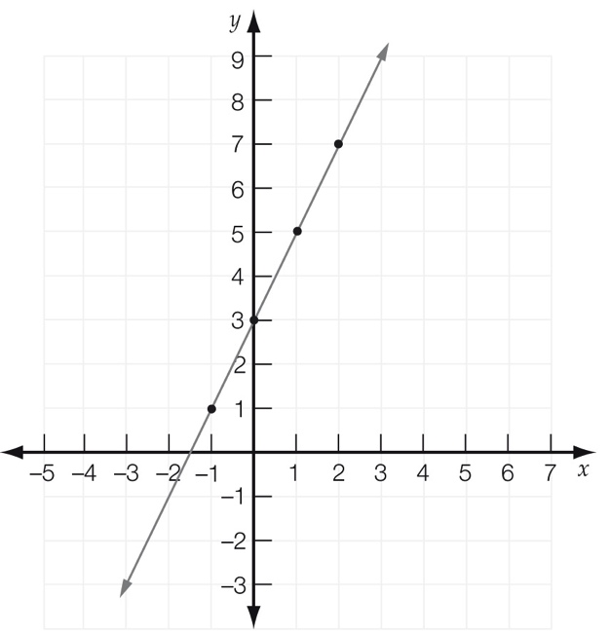

(b)

|  |  |  |  |  |
| --- | --- | --- | --- | --- |
| x | -1 | 0 | 1 | 2 |
| y | 1 | 3 | 5 | 7 |

(c) y = 2x + 3

(d) 2 × 20 + 3 = 43

So y = 43.

Question 34 3 marks [5.9]

S (5, 5); R (6, 8); T (5, 6)

Question 35 5 marks [5.9]

(a) Graph 4  
A and B must be level horizontally. C and D must be level vertically.

(b)

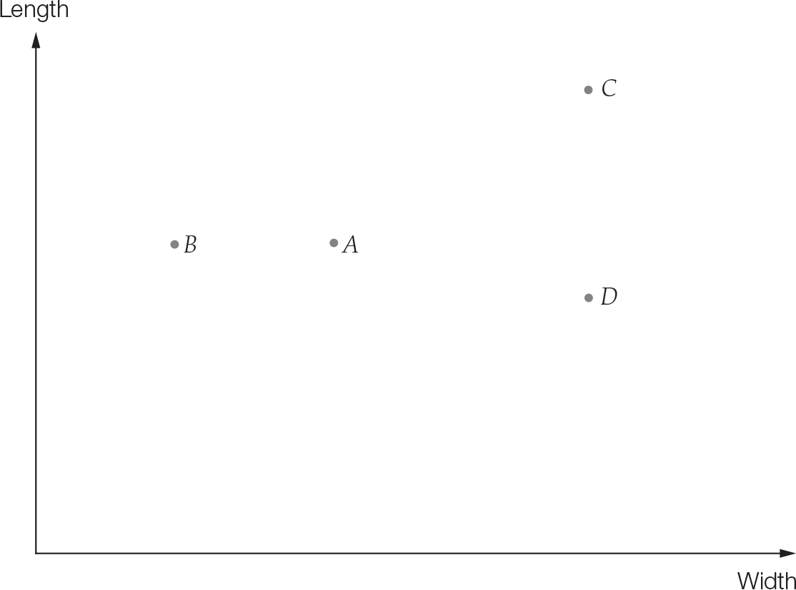

(c) Nail C

(d) Nail A

Question 36 11 marks [5.9]

(a) 6 pm

(b) 1 hour

(c) From 7 pm until 9 pm is 2 hours.

(d) From 6 pm until 7 pm is 1 hour.  
From 9 pm until 9:10 pm is 10 minutes.  
From 10 pm until 10:30 pm is 30 minutes.  
So, total time travelling is 1 hour 40 minutes.

(e) 40 km + 40 km = 80 km

(f) 35 km in  hour is a speed of 70 km/hour

(g) 35 km in 20 minutes is 3 × 35 km/hour  
So, speed = 105 km/hour

Short answer total: 96

Extended answer section

Question 37 3 marks [5.2]

(a) C = 4n + 2p + 3e

(b) 28 = 4n + 2p + 3e  
A possible set of numbers for n, p and e is  
n = 2, p = 4 and e = 4 because 4 × 2 + 2 × 4 + 3 × 4 = 28

Question 38 7 marks [5.3]

(a)

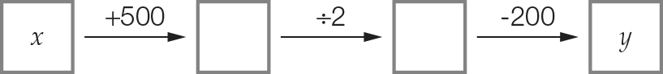

(b) y = 

(c)



(d) $5000 + $500 – $2950 = $2550 left

Question 39 6 marks [5.4]

(a) n = 10b + 30

(b) C = 

(c) C =  = 2 cans  
n = 10 × 140 + 30 = 1430 nails

(d) 3 cans of stain will cover 3 × 70 boards = 210 boards.  
Nails required = 10 × 210 + 30 = 2130 nails

Question 40 5 marks [5.6]

(a) Fifth deposit  
= x + 2 + 2 + 2 + 2  
= x + 8

(b) Total amount deposited  
= x + (x + 2) + (x + 4) + (x + 6) + (x + 8)  
= 5x + 20

(c) If final value is $80, then  
5x + 20 = 80

5x = 60

x = 12  
So the initial deposit is $12.

Question 41 4 marks [5.8]

(a)–(c)

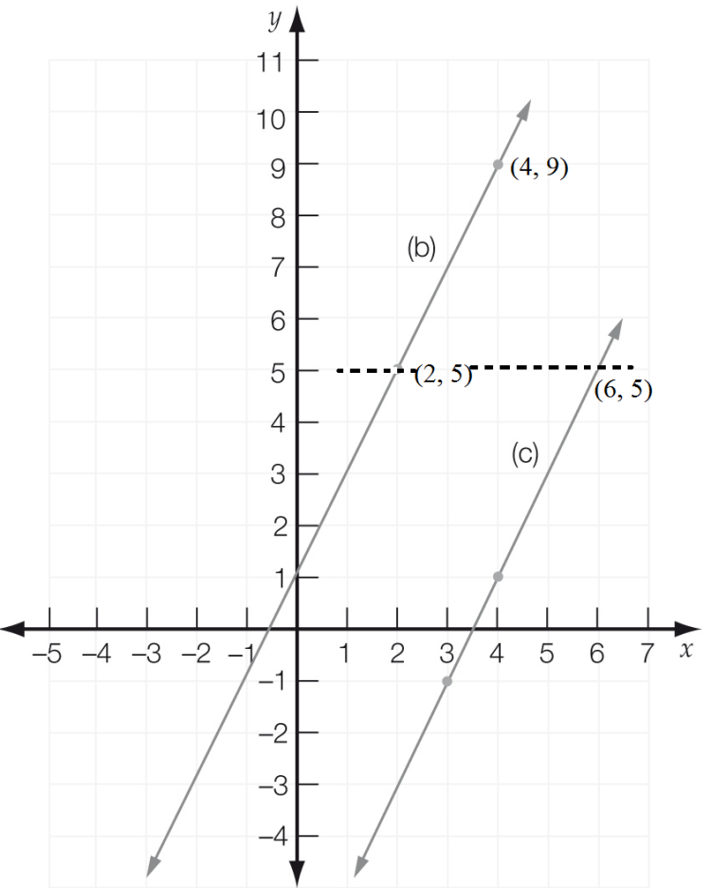

(d) From the diagram it can be seen that x = 6.

Extended answer total: 25

TOTAL test marks: 133